Introduction

The basic purpose of any communication system is to transmit some signal from a source to a destination through a media/ channel

Few examples of communication system

Eg.1 Radio
Source: Microphone → Captures signal & converts into electrical signal
Destination: Speakers in the Rx
Media/ Channel: Space

Eg.2: Television
Source: Video Camera & Microphone
Destination: Picture Tube & Speakers in the TV Receivers
Media/ Channel: Space

Eg.3: Telephone/ Cellular Mobile
Source: Microphone in phone set
Destination: Speaker in phone set
Media/ Channel: Wireline (Twisted pair wires) / Space

Eg.4: Storage Channels
CD, Magnetic disk, Magnetic tape, etc.

The source of the data for communication may be either Digital or Analog. For Digital Communication, the data has to be transmitted in digital form, so that the different schemes/ techniques can be used to transmit the data successfully. If the source is not in digital form, then it needs to be converted to digital form. In this situation, the communication block that is widely used in the A/D Converter or the Analog-to-Digital Converter.
The process of digitizing a signal involves two operations – a) Sampling & b) Quantization.

Sampling
Analog source, in general, generates a signal which is continuous is time. Even in a span of 1 sec, there are infinite instances and transmitting the signal for all instances is not an easy task. The values for every time instant need to be discrete. Hence, at regular intervals the time stamps are collected; then the values of the signal at those time stamps are noted. These values are prepared for transmission.

Quantization & Coding
After sampling, the sample values of the signal at discrete time intervals are still analog in nature. Now, the sample values (amplitude) are discretized. A finite number of values are considered as representative values; for each such case, a particular value is so chosen, which is close to the exact value and are tagged as representative values. These representative values / levels chosen within a certain range are now encoded. Because of this process, some errors creep in and there is a scope for loss of information. Hence, more number of levels are taken so that the quantization noise is small enough within tolerance limit.

Modern Concept of a Digital Communication System
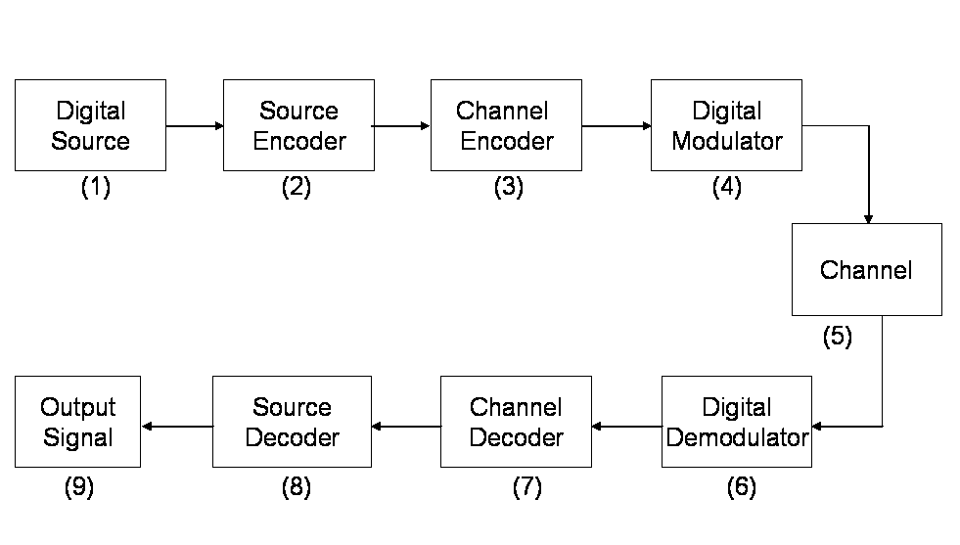
Fig.1: Block Diagram of a Digital Communication System

- Digital Source can be thought of as a Binary Source as well. Encoding by different rules get a ‘0’ & ‘1’ coding scheme available.
- Compresses the data to a minimum number of bits. It is not expected to use more bandwidth to transmit same amount of data. In digital source, there is a chance of having more number of redundant bits which may be compressed in the source encoder by the use of some software like gunzip, etc. (Some source coding techniques also play a role). Redundancy occurs when (a) ‘0s’ & ‘1s’ are not equi-probable; (b) there may be correlation between the consecutive bits. Example, in an image signal, there is a high correlation between the neighboring pixels, (if a blue pixel is present, there is a high probability of the neighboring pixels to be blue). As a result, it may be inferred that all the pixels do not carry relevant information.
- Receives the bits and transmits the signal in a way suitable for the channel. It takes care of the channel and then tries to shape the signal in a way that the receiver will be able to get maximum information from what it receives. A traditional way to do channel coding is Error Correction Coding.
- Specially used for analog channels. Most of the channels are analog in nature. So, for a digital modulator, the input is digital, but the o/p is analog in nature.

- The channels may be wireline, fiber optic cable, space, storage channel (magnetic recording channels), underwater acoustic channel (where signal is transmitted from one point under the sea to another point under the sea). Now, if the channels behaved in a deterministic manner, i.e. if it is known how the channel will affect the signal while it is being transmitted, the job of the designer (Rx) would be simple. The idea is to get the transmitted signal back, in one sense; the job of the receiver is to invert the entire process up to the stage of the channel. However, in practice, the channels are not deterministic, the main reason being the Noise in the channel. The noise may be in the channel or in the Rx. The noise may be introduced because of various reasons:- thermal noise, flicker noise, man-made noise, lightning, switching, impulse noise; the most predominant being the thermal noise.
Noise in general, is random in nature. There is no way to predict the value the noise will take at any point of time. So, the question arises as to what can be known about the noise? It is often mentioned that the statistics of the noise is known and is estimated by performing experiments or generating models for the noise that are reasonably good for practice.
Thermal noise is modeled as Gaussian Noise. The most common type of channel that we come across is Additive White Gaussian Noise (AWGN) Channel. In this channel model, the transmitted signal goes through a deterministic change in the channel and then a Gaussian noise is added.

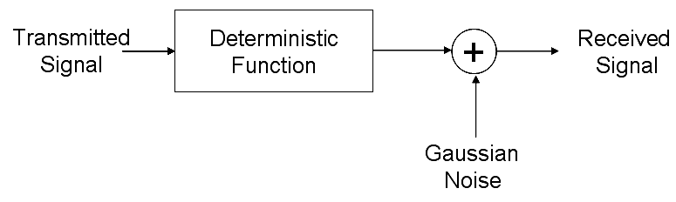
Fig. 2: Model to generate Thermal Noise

The block highlighted as “Gaussian Noise” is the Fig. 2 is basically the thermal noise generated at different points in electronic device in the receiver.
So, thermal noise is modeled as Gaussian Noise and added to the system. This Gaussian Noise is assumed to be white, i.e. it is ‘uncorrelated’. That means at any instance of time, the noise value obtained has got no correlation with any other value at any other instance of time.

- Digital demodulator tries to estimate the bits that were intended to be transmitted from the waveform it receives. The output is generally in bits.
- Channel decoder will try to correct some errors, if any. The channel might have introduced some distortions due to which the digital demodulator might have detected some bits wrongly. This can be revisited and corrected with the help of the extra bits transmitted by the channel encoder as redundant bits.
- Source decoder reproduces the output signal.

Channel is the physical medium. It can be thought of as an abstraction that models the effects (good or bad) that is introduced into the communication system, more precisely the signal used for transmission.

Types of Communication Channels

  - EM Wave Propagation Channel (Free Space Channel)
  - Guided wave Electromagnetic Wave propagation channel
  - Optical Channels

Bandwidth of a Channel – refers to the frequency range over which it can support propagation of radio waves or any other waves. Typically, this can be visualized as a filter that will either pass a certain frequency or attenuate below a certain frequency. An optical fiber provides a larger bandwidth than a cable.

